**19CSE205 – Program Reasoning**

**Assignment – 4**

S. Abhishek

AM. EN. U4CSE19147

* 1. **Deduce the weakest precondition for the given program S and postcondition Q.**

|  |  |
| --- | --- |
| P |  |
| S | a = a + 3  b = b - 2 |
| Q | **a * b == 0** |

**Post Condition Q is a * b == 0.**

* wp (a = a + 3; b = b – 2, a * b = = 0)
* wp (a = a + 3, wp (b = b – 2, a * b = = 0))
* wp (a = a + 3, a * b – 2 = = 0)
* a + 3 * b – 2 = = 0
* (a + 3) * (b – 2) = = 0
* a = -3 \/ b = 2

P → a = -3 \/ b = 2

* 1. **Show that the input condition P’: 1 <= n <= 3 is necessary and sufficient to guarantee the output condition**

**Q’: p == 1 \/ p == 2 \/ p == 6 for the given program S.**

|  |  |
| --- | --- |
| S | p = 1  i = 1  **if** i <= n **then**  p = p * i  i = i + 1  **if** i <= n **then**  p = p * i  i = i + 1  **if** i <= n **then**  p = p * i |

**B1 → if** i <= n **then**

p = p * i

i = i + 1

**B2 → if** i <= n **then**

p = p * i

i = i + 1

**B3 → if** i <= n **then**

p = p * i

Q’ → p==1 \/ p==2 \/ p = = 6

Post Condition Q = Q’

P = wp (S, Q) --> P => Q

Q’ = p==1\/p==2\/p==6

Q3 = wp (if i<=n then p=p*i, Q’)

Q3 = wp (if i<=n then p=p*i, p==1\/p==2\/p==6)

Q3 = i<=n /\ wp (p=p*I, p==1\/p==2\/p==6)

Q3 = i<=n /\ (p*i==1\/p*i==2\/p*i==6)

Q2 = wp (if i<=n then p=p*i /\ i=i+1, Q3)

Q2 = i<=n /\ wp [ p=p*i; i=i+1, i<=n /\

(p*i==1\/p*i==2\/p*i==6)]

Q2 = i<=n /\ wp [ p=p*i, wp (i=i+1, i<=n /\

(p*i==1\/p*i==2\/p*i==6))]

Q2 = i<=n /\ wp [ p=p*i, i+1<=n /\

(p(i+1) ==1\/p(i+1) ==2\/p(i+1) == 6)]

Q2 = i<=n /\ i+1<=n /\

(p*i(i+1) == 1\/p*i(i+1) == 2\/p*i(i+1) == 6)

Q1 = wp (if i<=n then p=p*i /\ i=i+1, Q2)

Q1 = i<=n /\ wp [p=p*i; i=i+1, i<=n /\ i+1<=n /\

(p*i(i+1) == 1 \/p*i(i+1) == 2\/p*i(i+1) == 6)]

Q1 = i<=n /\ wp [ p=p*i, wp (i=i+1, i<=n /\ i+1<=n /\

(p*i(i+1) ==1 \/p*i(i+1) ==2\/p*i(i+1) ==6))]

Q1 = i<=n /\ wp [ p=p*i, i+1<=n /\ i+2<=n /\ ( p(i+1)(i+2)==1 \/p(i+1)(i+2)==2\/p(i+1)(i+2)==6 )]

Q1 = i<=n /\ i+1<=n /\ i+2<=n /\ (p*i(i+1) (i+2) ==1 \/

p*I (i+1) (i+2) ==2\/p*i(i+1) (i+2) ==6)

P’ = wp (p=1; i=1, Q1)

P’ = wp [p=1, wp [ i=1, i<=n /\ i+1<=n /\ i+2<=n /\

(p*i(i+1) (i+2) ==1 \/ p*i(i+1) (i+2) ==2\/p*i(i+1) (i+2) ==6)]]

P’ = wp [p=1, 1<=n /\ 2<=n /\3<=n/\ (p (2)(3) ==1 \/

P (2)(3) ==2 \/ p (2)(3) ==6)]

P’ = 1<=n /\ 2<=n /\ 3<=n /\ (6==1 \/6==2\/6==6)

P’ = 1<=n /\ 2<=n /\ 3<=n /\ (False \/ False \/ True)

P’ = 1<=n /\ 2<=n /\ 3<=n /\ True

P’ = 1<=n /\ 2<=n /\ 3<=n

P’ = 1<=n<=3

**Hence P: 1 <= n <= 3**

**C. Show the proof of successful installation and working of frama-c on your laptop by providing the following information.**

**Output of the command:** frama-c -version

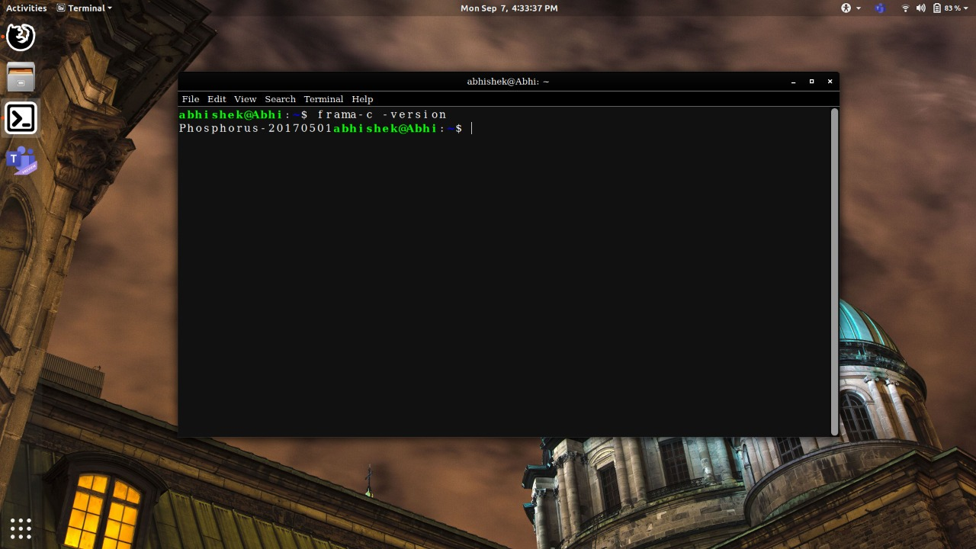

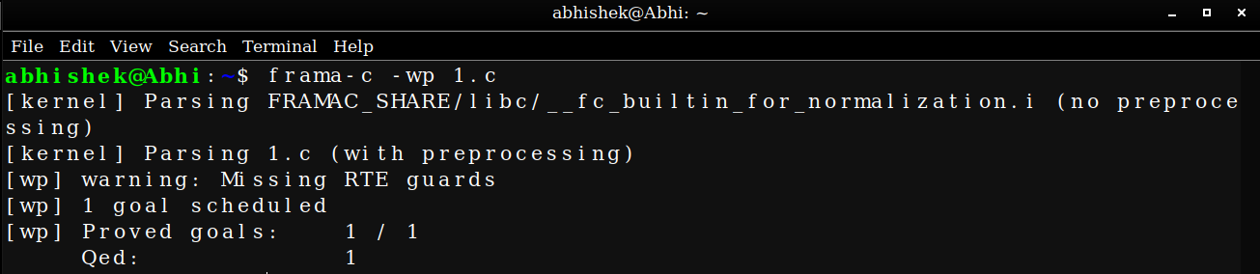

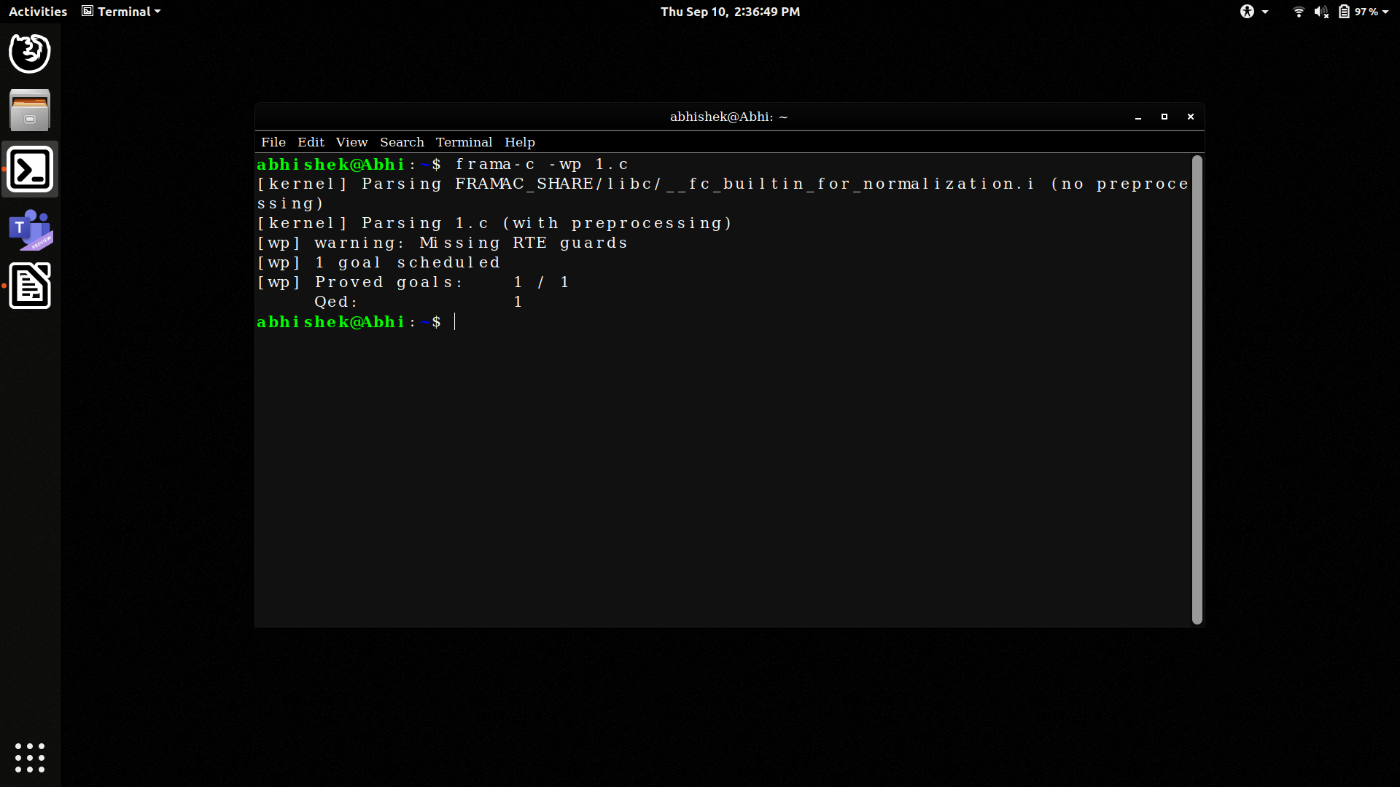

THANK YOU